Sun Safety Policy
Too much exposure to ultraviolet (UV) radiation from the sun causes sunburn, skin damage and increases the risk of skin cancer. Sun exposure in the first 15 years of life contribute significantly to the lifetime risk of skin cancer. At Birchfield Nursery we want all staff and children to enjoy the sun safely. We will promote Sun safety through working with parents, staff, and the wider community to improve our understanding and provision to avoid the harmful effects of too much exposure to UV. Staff should always act as a positive role model and set a good example by seeking shade whenever possible, wearing appropriate clothing, and applying sunscreen
Education
- All children will be involved in a discussion, appropriate for their age and understanding, at the start of summer about sun protection and the risks
- All staff will be educated in the importance of sun protection and the risks involved in not protecting both themselves and others
- Parents and carers will be informed about our policy
Protection
- The nursery garden has shade provided with outdoor shelter and large trees
- Children will be encouraged to use the shaded areas during playtimes when appropriate
Clothing
- The children will be encouraged to wear clothes that provide good sun protection (sun hats etc)
- Parents/carers will be duly informed of the importance to provide the nursery with the appropriate clothing/headwear
- Staff should wear hats when appropriate to act as a good role models and to also demonstrate drinking plenty of water
- Children are encouraged to increase their water intake in hot weather and are encouraged to do so in outdoor areas also.
- Water will always be available to children throughout the day from water dispensers which children will be able to access independently. (both indoors and outdoors)
Sunscreen
- Parents of children that attend for a half day should apply sun cream to their child at home. For those children that attend for a full day, parents should apply cream to their children before they come to nursery and staff will assist the child in re-applying it during the day when necessary.
- Parents are asked to give written permission for sun cream to be applied to their children.
- Nursery will provide sun cream for 30-hour children in agreement with parents.
- Parents will be informed of the sun cream available to children.

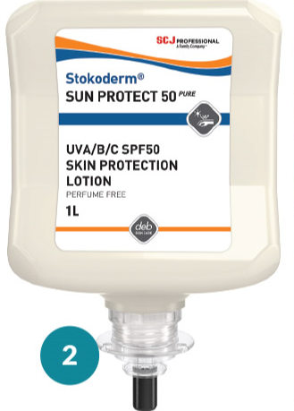

Deb Stokoderm Protect Pure
- Proven general-purpose protection - Suitable for a wide range of working environments with light to moderate exposure to varying types of water and non-water based substances.
- Quick-drying - Leaves a pleasant, non-tacky protective film on the skin to encourage regular use and does not affect dexterity with handheld tools.
- Contains Xanthan Gum - Highly effective polymer which is used to stabilise the protective film provided by the product when applied to the skin.
- Contains Kaolin - A natural mineral which sits in the skin pores to help prevent them from becoming blocked by oil-based substances
- Contains Glycerin - Enhances the water holding capacity of the skin’s upper layers, supporting the skin’s own moisture system and natural barrier function.
- Non-tainting and assessed according to HACCP guidelines - When used as directed in food production and preparation areas, the product does not influence the quality of foodstuffs or present any risk to the health of its consumers.
- Proven glove compatibility - Suitable for use with latex, vinyl and nitrile gloves.
- Perfume-free - No added perfume. Ideal for people who are sensitive to perfumes and prefer products which do not have perfume added.
- Silicone-free - The product will have no adverse effect if in contact with surfaces prior to the application of paint or surface coatings.
- Compatible with rubber production processes - Independently tested at the German Institute of Rubber Technology (DIK) and proven to have no negative effect on the vulcanisation process.

